**Project Design Phase-II**

**Data Flow Diagram & User Stories**

| Date | 06 May 2023 |
| --- | --- |
| Team ID | PBL-NT-GP-5215-1680777299 |
| Project Name | smart billing system for water suppliers |

**Data Flow Diagrams:**

A Data Flow Diagram (DFD) is a traditional visual representation of the information flows within a system. A neat and clear DFD can depict the right amount of the system requirement graphically. It shows how data enters and leaves the system, what changes the information, and where data is stored.



**Example:** [**(Simplified)**](https://developer.ibm.com/patterns/visualize-unstructured-text/)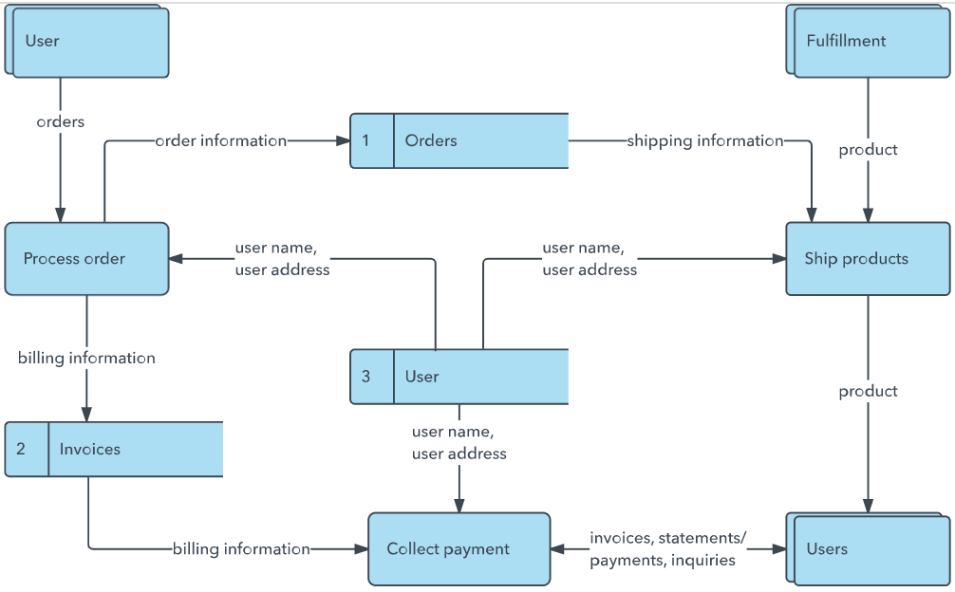

**User Stories**

Use the below template to list all the user stories for the product.

| **User Type** | **Functional Requirement (Epic)** | **User Story Number** | **User Story / Task** | **Acceptance criteria** | **Priority** | **Team Member** |
| --- | --- | --- | --- | --- | --- | --- |
| Customer (Mobile user) | Registration | USN-1 | As a user, I can register for the application by entering my email, password, and confirming my password. | I can access my account / dashboard | High | Shivam |
|  |  | USN-2 | As a user, I will receive confirmation email once I have registered for the application | I can receive confirmation email & click confirm | High | Shivani |
|  |  | USN-3 | As a user, I can register for the application through Facebook | I can register & access the dashboard with Facebook Login | Low | Shivam |
|  |  | USN-4 | As a user, I can register for the application through Gmail | A billing system is a procedure used by a company to charge and invoice clients, to put it simply | Medium | Shivam |
|  | Login | USN-5 | As a user, I can log into the application by entering email & password | tracking expenses and tracking invoices are frequently included in billing systems. | High | Sandeep |
|  | Dashboard | USN-6 | As a user,I can use the dashboard to enter in a project phases | I can use the dashboard with the email to login and enter to the project | Medium | vinodhini |
| Customer (Web user) |  | USN-7 | Your water bill pays for drinking water and wastewater services. | a regular charge that is made to people for the use of their local water supply. | low | naveen |
| Customer Care Executive |  | USN-8 | Smart Billing is service agnostic and allows any type of service offering and. business model, through one unified platform | It fully supports both prepaid and postpaid. business models. | high | tharun |
| Administrator |  | USN-9 | manage transaction such as creating an invoice and paying the bills of customers. | It will track all the records of the customer if they have paid on the due date or not. | medium | pavithra |
|  |  | USN-10 | Your water bill pays for drinking water and wastewater services. | Closed Medical Billing Systems. Open Medical Billing Systems. Isolated Medical Billing Systems. | high | vinodhini |
|  |  |  |  |  |  |  |
|  |  |  |  |  |  |  |